AWS TASK – 1
Task Description:

Create a windows Vm machine in AWS and connect with RDP open CMD in windows share the about system info.

Created EC2 Instance with Microsoft windows server

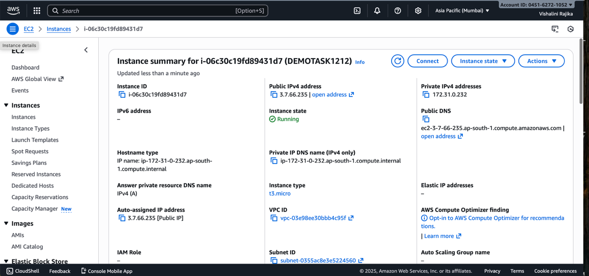

Connecting the instance using RDP client and taking password and username.
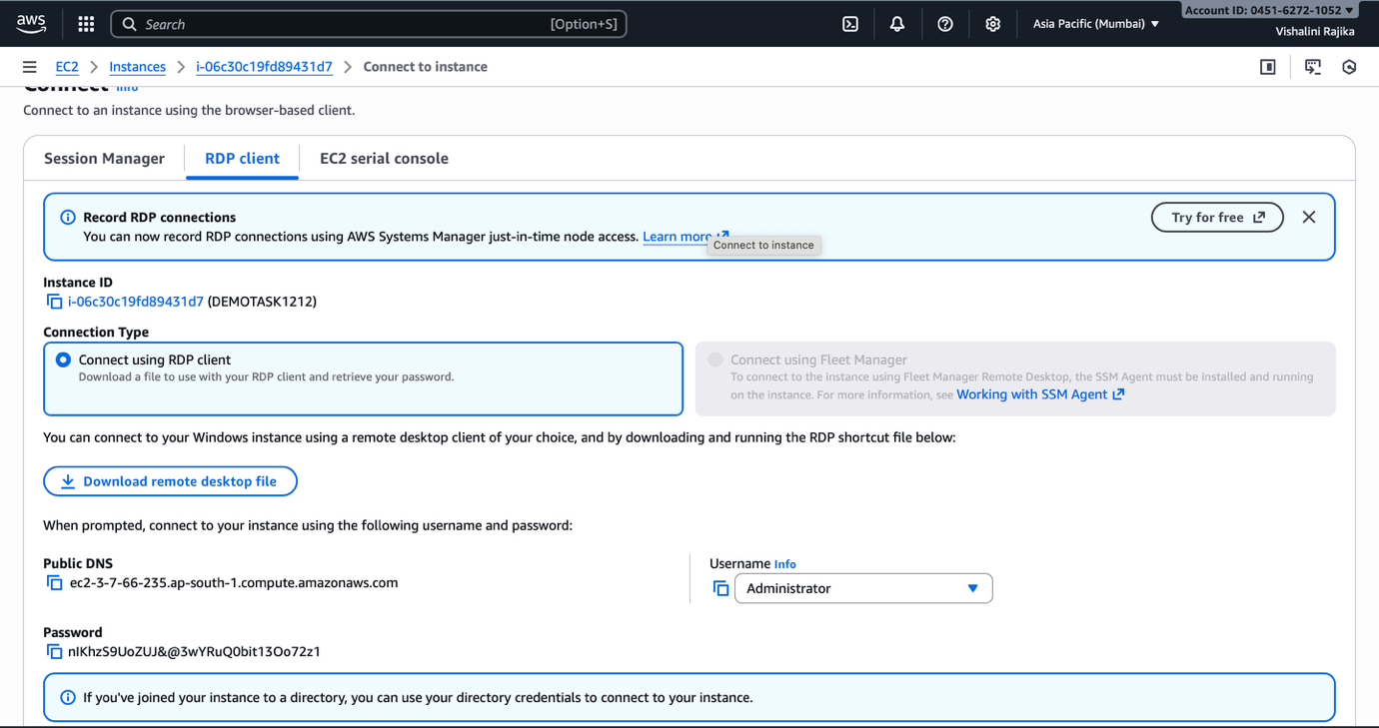

After connecting windows vm system info
OUTPUT:
